**SQL ASSIGNMENT-2**

1. Retrieve all columns from the Sales table.

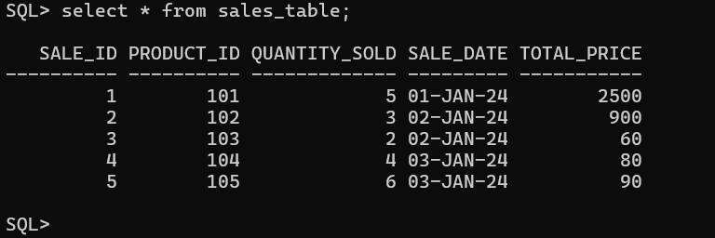

2. Retrieve sale_id and quantity_sold from sales table.

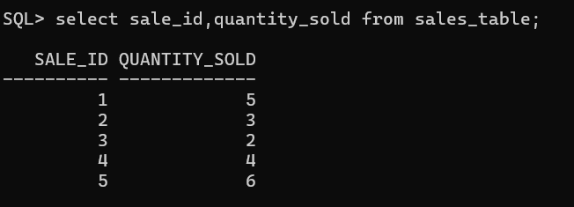

3. Retrieve the sale_id and sale_date from the Sales table.

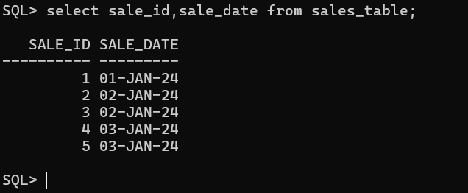

4. Filter the Sales table to show only sales with a total_price greater than $100.

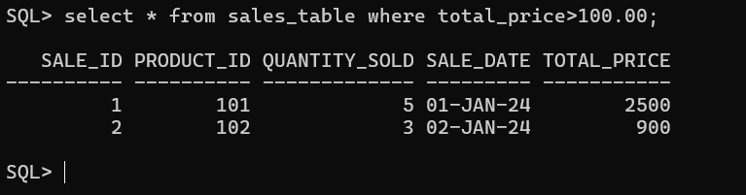

5. Retrieve the sale_id and total_price from the Sales table for sales made on January 3, 2024.

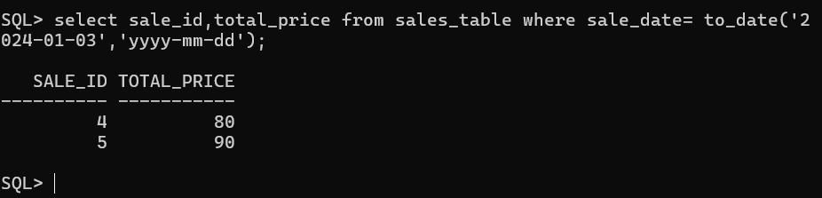

6. Retrieve the sale_id, product_id, and total_price from the Sales table for sales with a quantity_sold greater than 4.

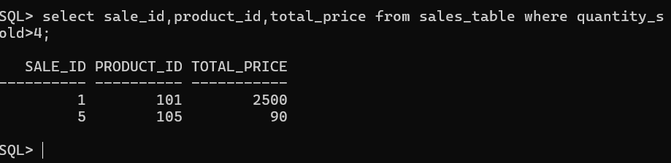

7. Retrieve all columns from the Sales table those sale_id are 1, 3 & 5.

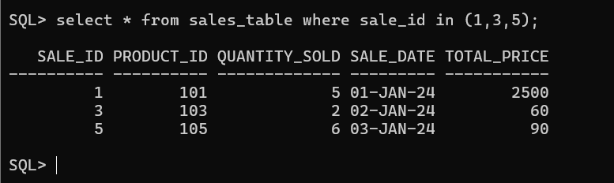

8. Retrieve all columns from the Sales table those total_price between 90 and 1000.

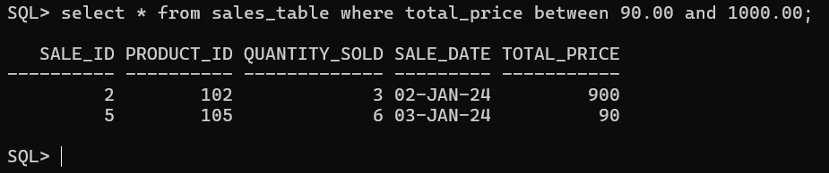

9. Retrieve all columns from the Sales table those total_price not between 90 and 1000.

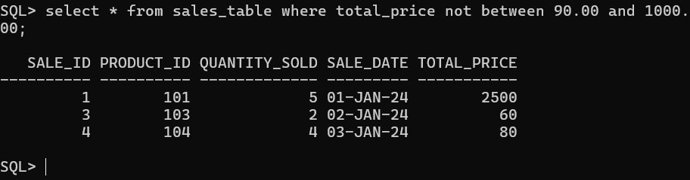

10. Retrieve all columns from the Sales table those sale_id are not in 1, 3 & 5.

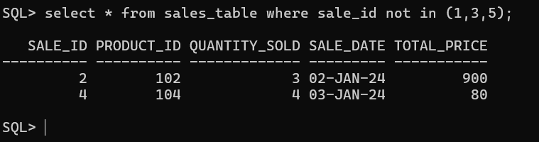

11. Update total_price as 500 in the Sales table those sale_id are 1, 3 & 5.

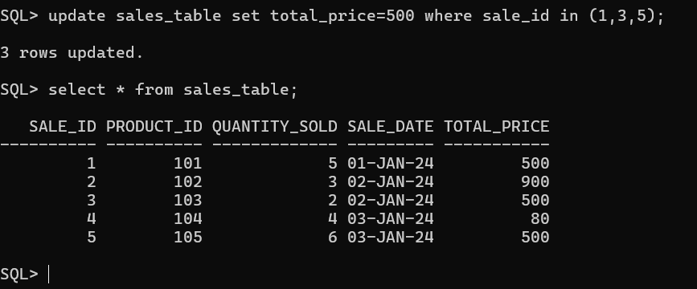

12. delete from the Sales table those total_price not between 90 and 1000.

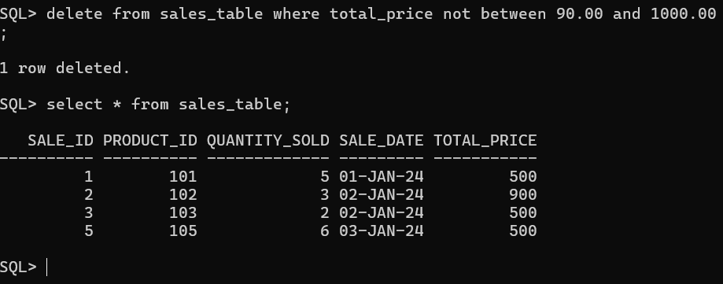

13. Sort all the records using sale_id column in ascending order.

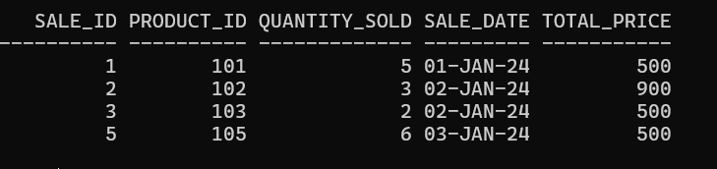

14. Sort all the records using sale_id column in descending order.

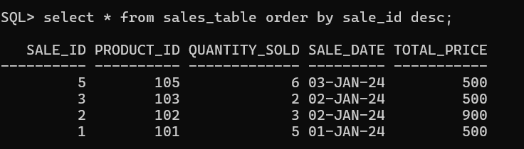

15. Rename the sale_id column as sales_id.

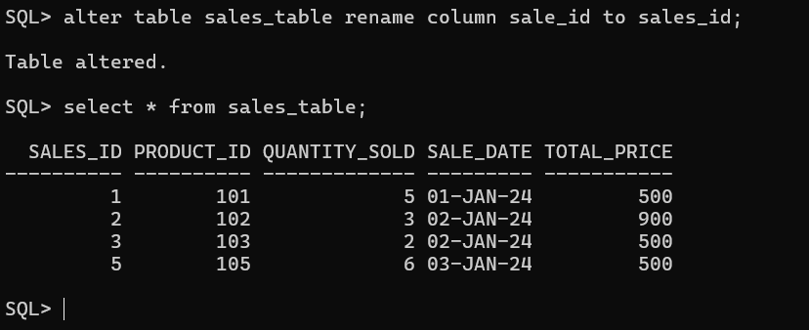

16. Drop the column sales_id.

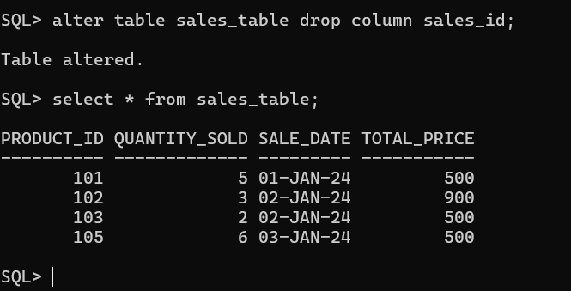

17. Rename the table as tbl_sales.

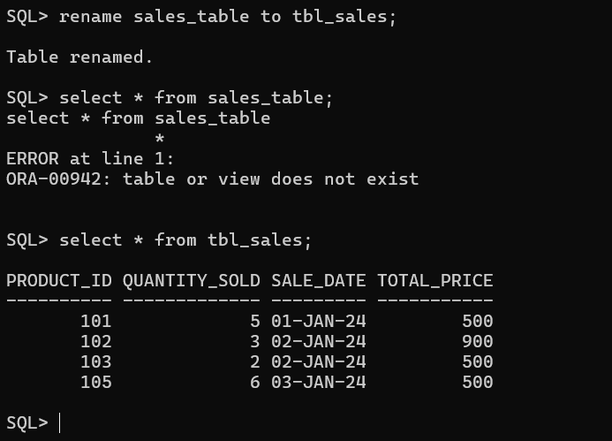

18. Drop the table.

